- Use comments field on the mashup to allow maintain any extra comments plus the actual user recording the test results. This information should then be recorded against the test on the request ID and displayed both in M3 (QMS400/B1) and on the Mashup.
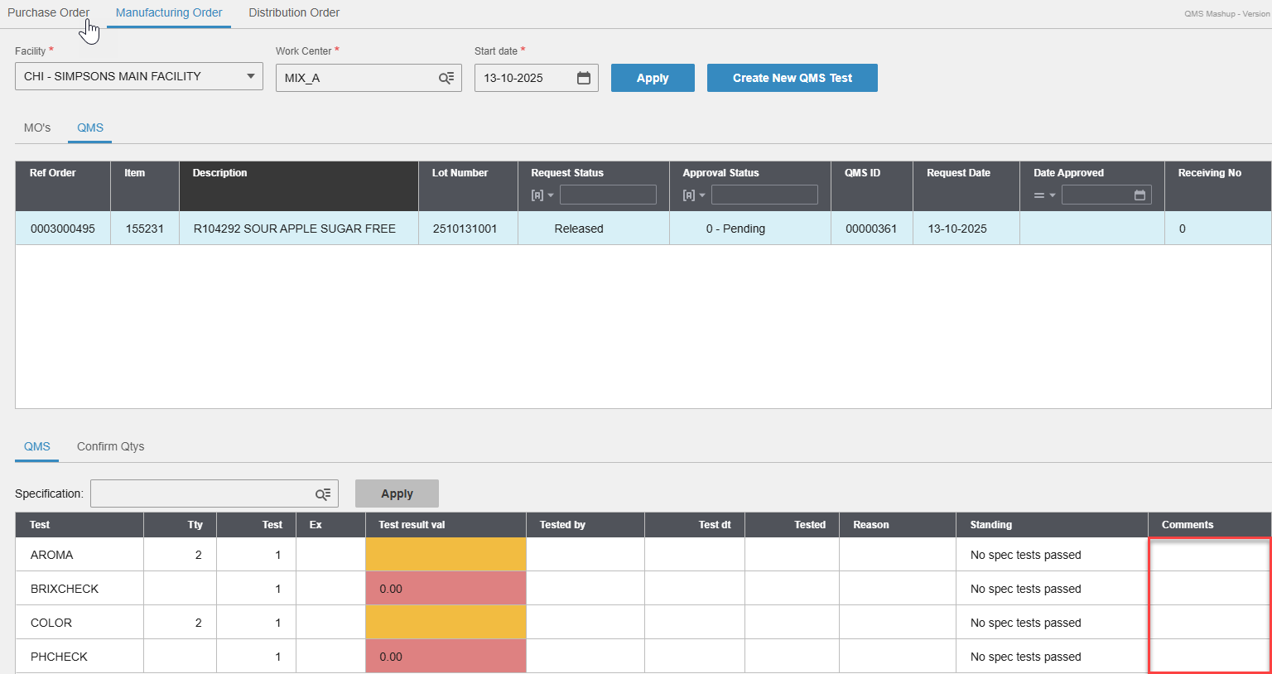
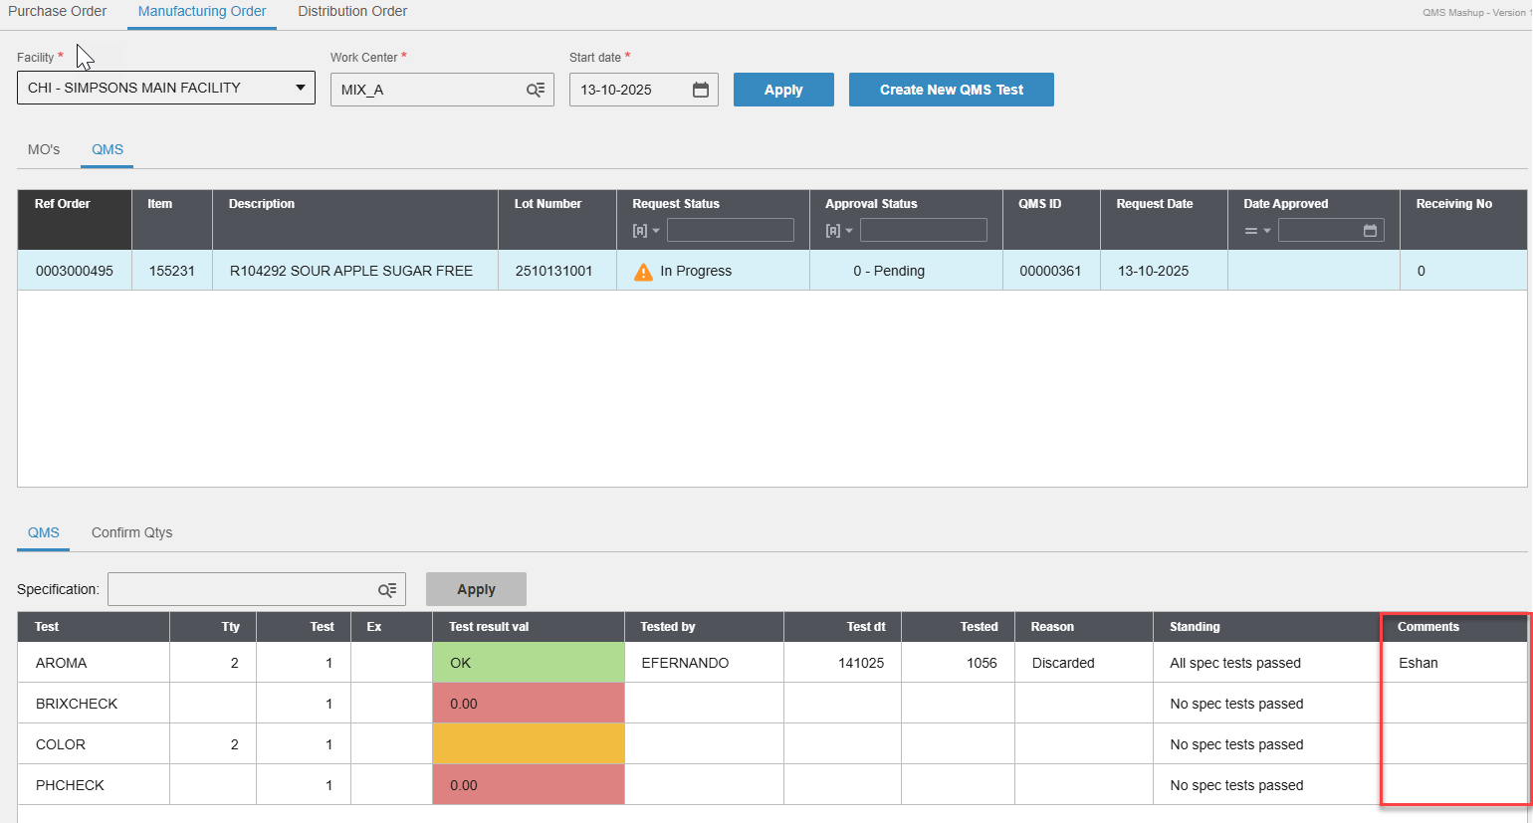
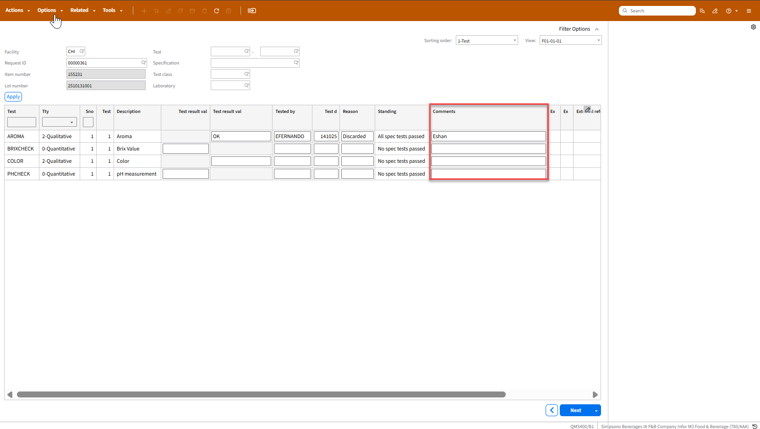
API to update comments against tests.
  - API: QMS400MI
  - Transaction: UpdTestResult
Description | Field | Test Value | Extraction Method
Facility | FACI | SB1 | Facility on QMS Mashup screen
Request ID | QRID | 00000015 | QMS ID on QMS tab within the Mashup
Test | QTST | APPEARANCE | Individual test on QMS Mashup screen
Test type | TSTY | 2 | Value on Tty column on QMS Mashup. If blank set to 0
Test sequence | TSEQ | 1 | Maintain as a configurable field if needs amending later
Value entered | VLEN | 1 | Maintain as a configurable field if needs amending later
Comments | SI01 | Test | Map to comments column on the Mashup
Table 1: Update comments against Tests
- Target value, expected minimum, expected maximum values on QMS201 record (Item, specification record) to be displayed on ‘Ex’ column on the Mashup
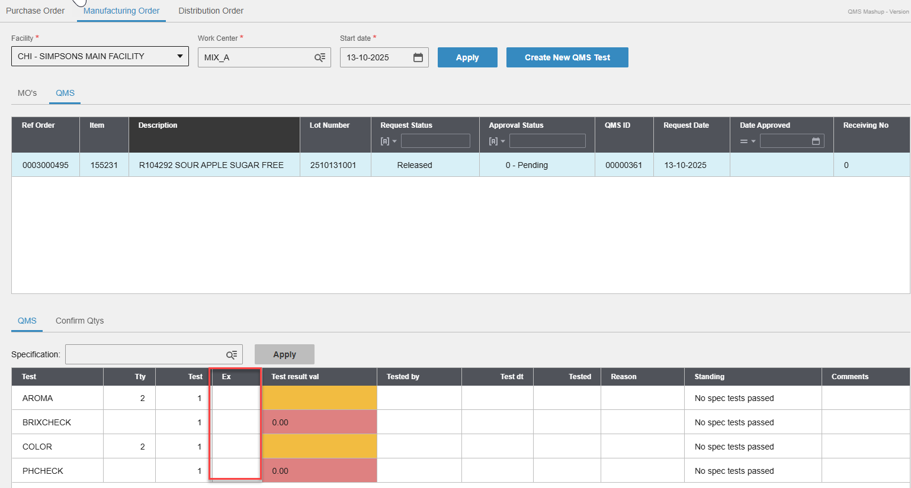
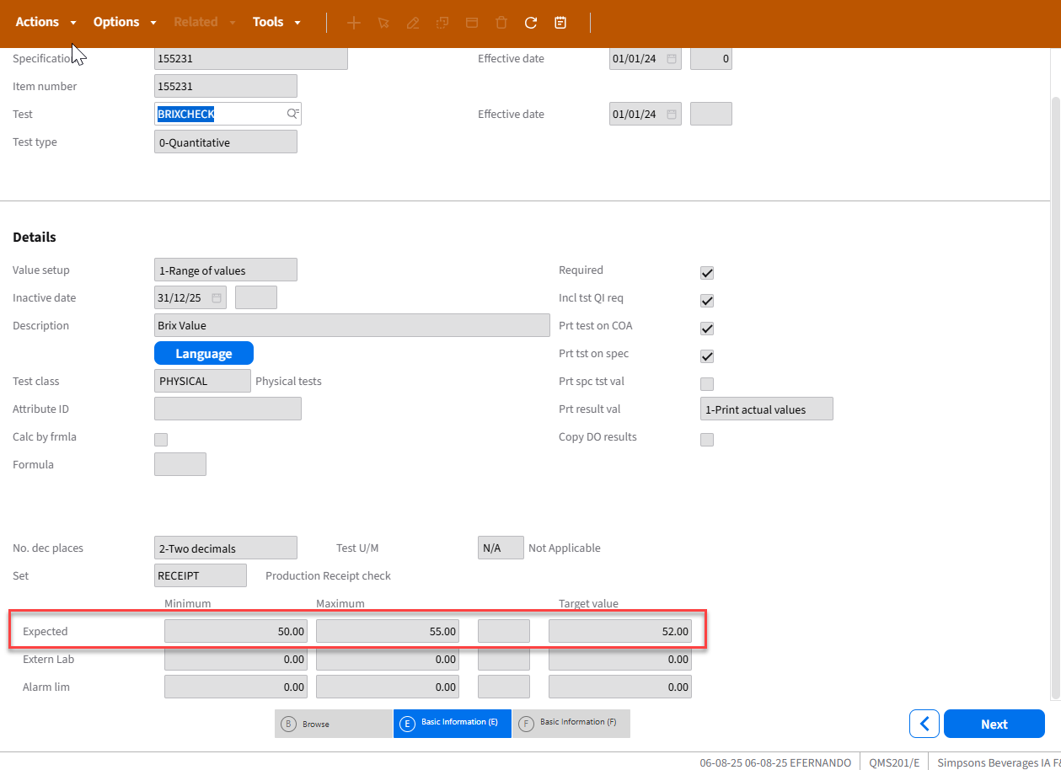
API to retrieve expected, minimum and maximum values against tests.
  - API: CMS100MI
  - Transaction: LstQISpecTest
Description | Field | Test Value | Extraction Method
Item Number | ITNO | 153228 | Item on QMS tab within the Mashup
Specification | SPEC |  | Item on QMS tab within the Mashup
Test | QTST | APPEARANCE | Individual test on QMS Mashup screen
Table 2: Listing Specification Tests against items
Based on inputs to Table 2, below outputs are obtained.
Description | Field | Test Value
Test | QTQTST | ACIDITY
Test type | QTTSTY | 0
Effective date | QTQTE1 | 010125
Inactive date | QTQTI1 | 311228
Description | QTTX40 | Acidity check
Table 3: Outputs from CMS100MI: LstQISpecTest
- Remove the ‘Start date’ filter on Manufacturing Order tab
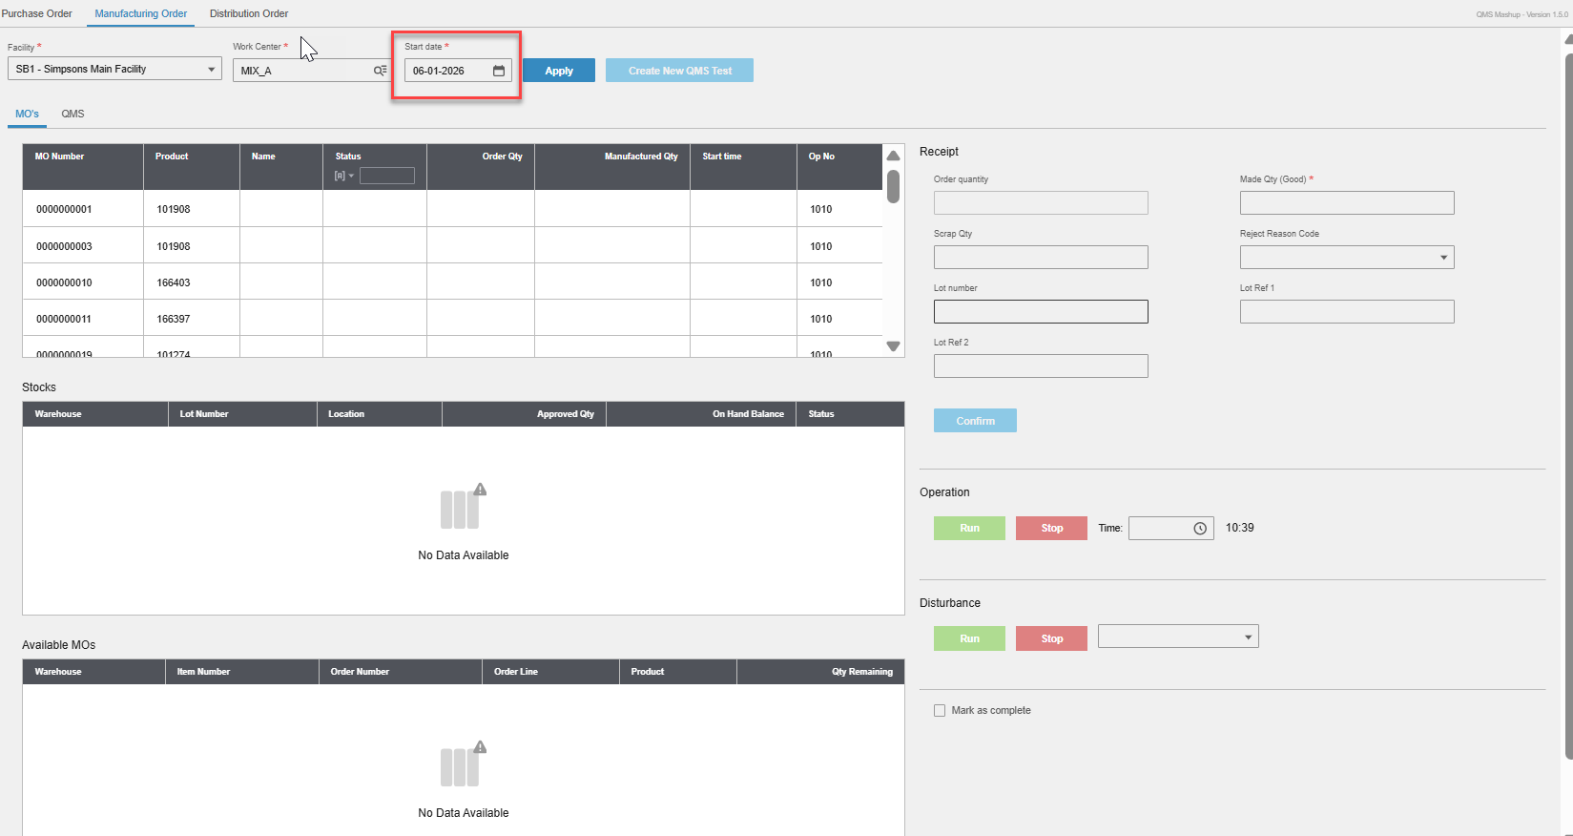
- Pre-populate start date to be -7 to +7 based on Today’s date. I’ve added start date as a selection field to CMS100MI: LstMOWorkCtr. However, this needs to be an input to F_STDT and T_STDT fields on the API input. We’ll have to add that to QMS Mashup code

- Once test result values are entered on QMS Mashup and the screen exited, entered test result values should be locked meaning no one should be able to return to the Mashup and edit test result values entered
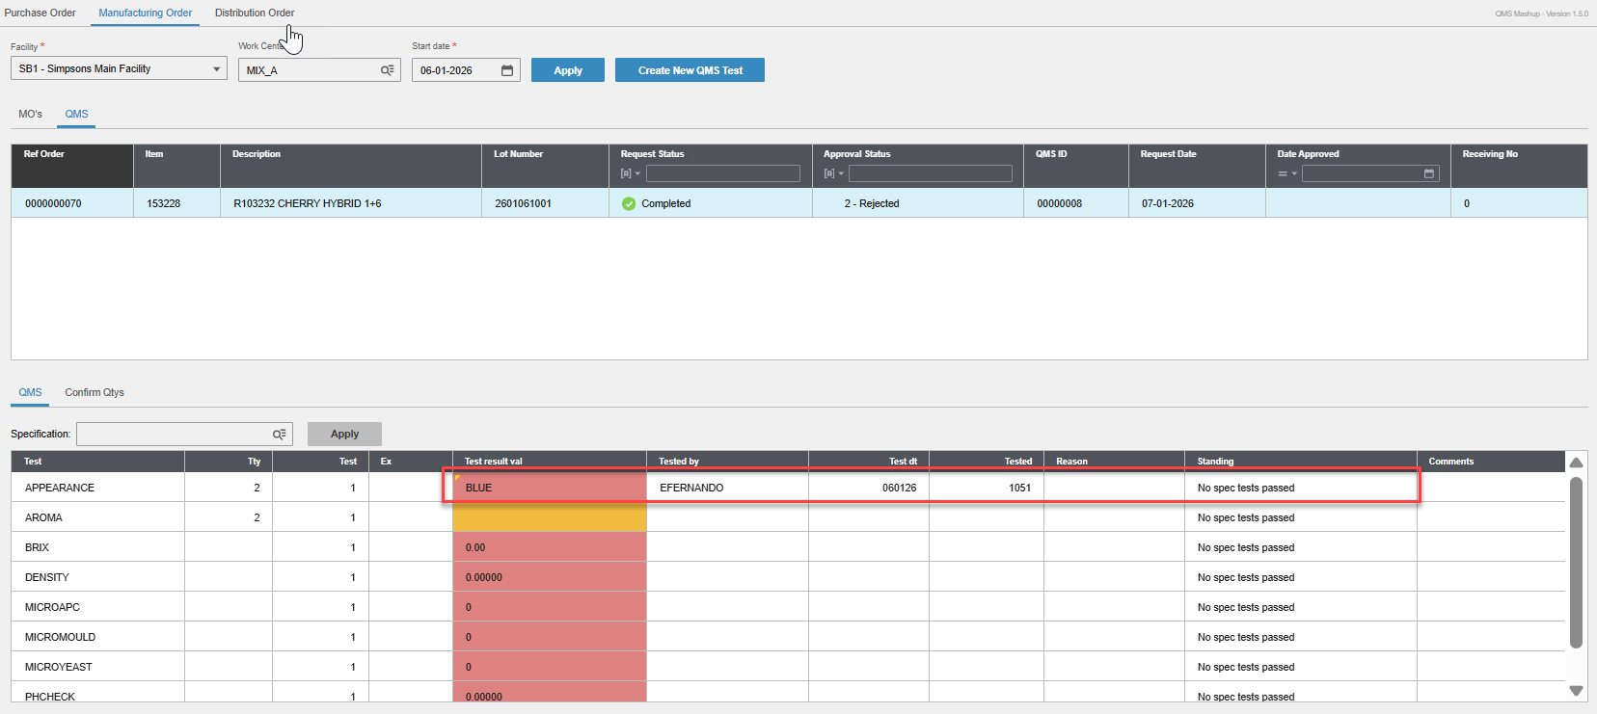

- When weight check test result values are entered against a pack order, test results inherited from the recipe order should be locked and no longer editable on the screen
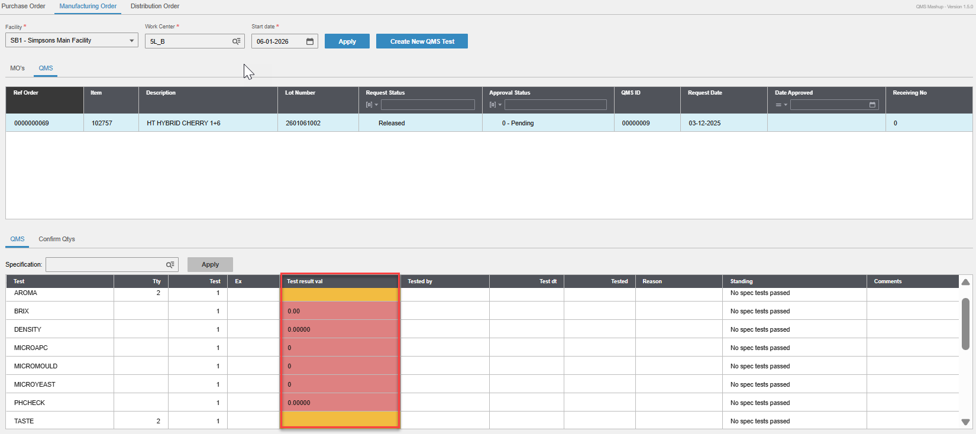
- Tty, Test, Reason columns to be removed while Comments column to be made bigger
